**Working with Commands Lab**

## Accessing the AWS Management Console

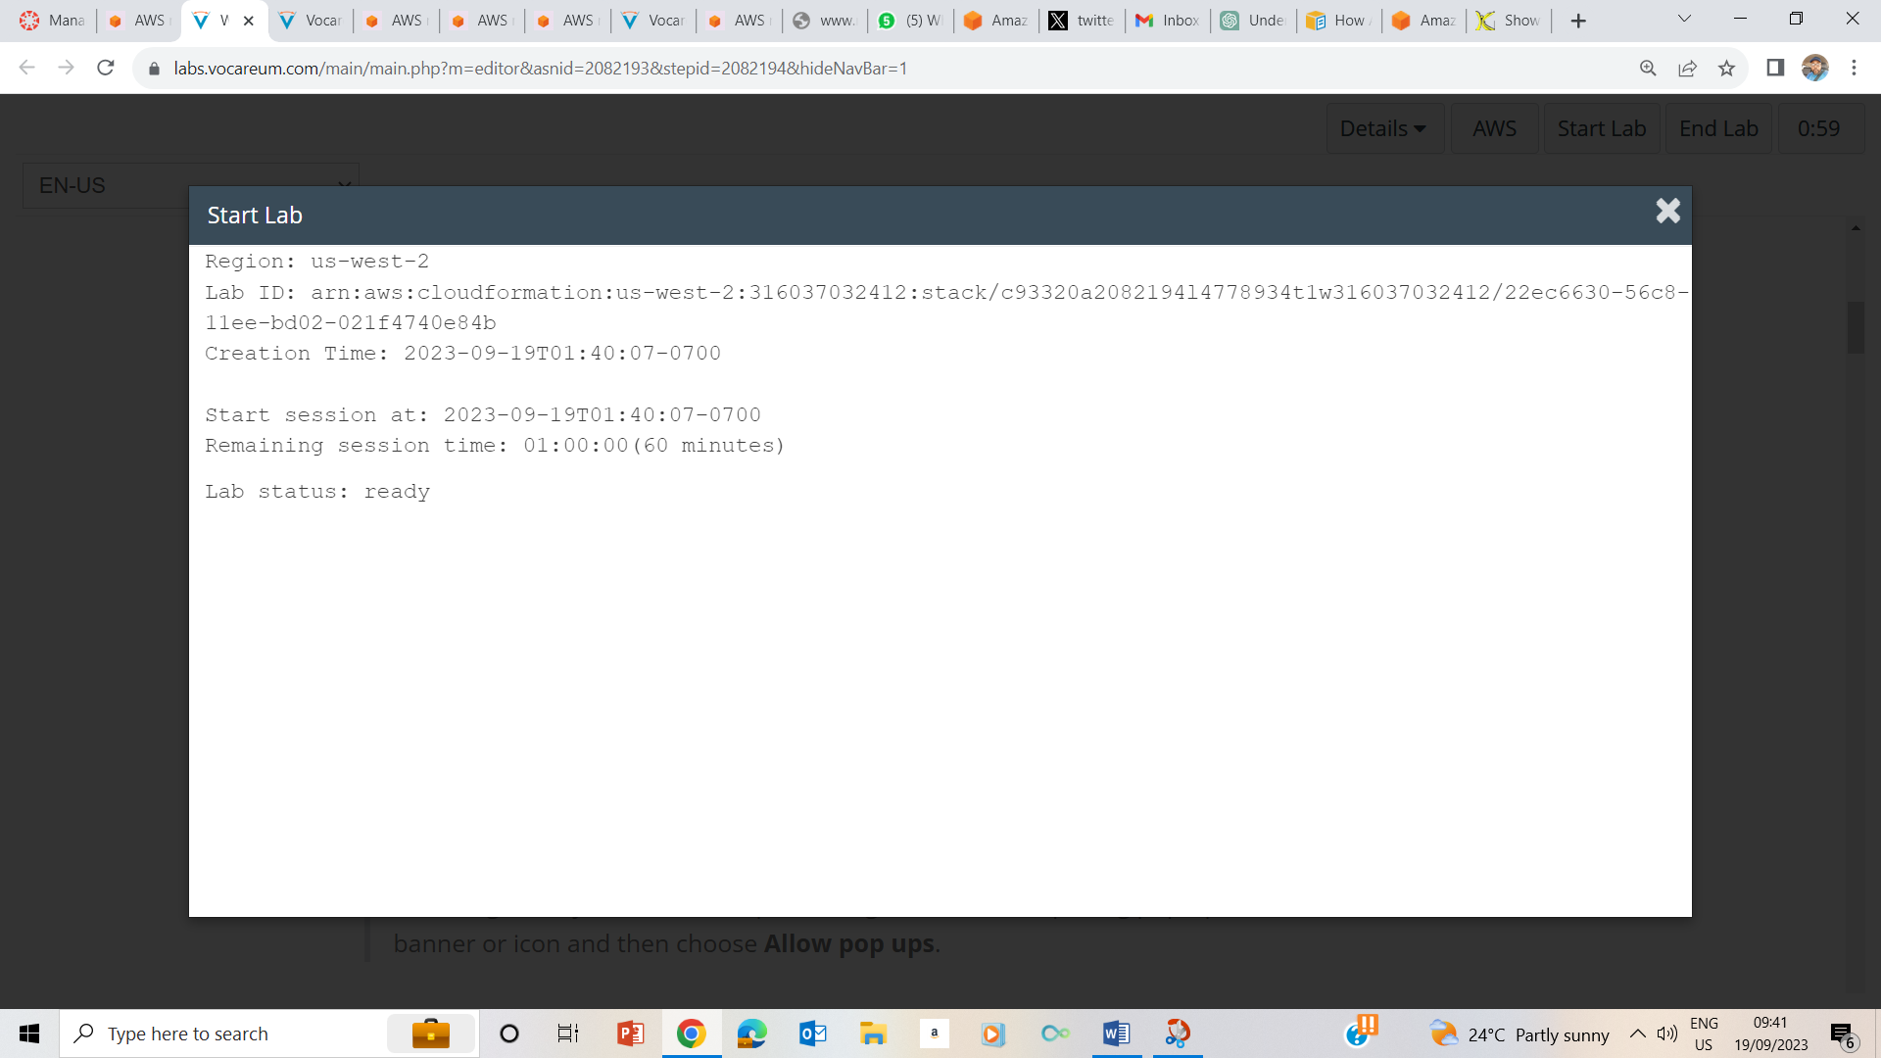

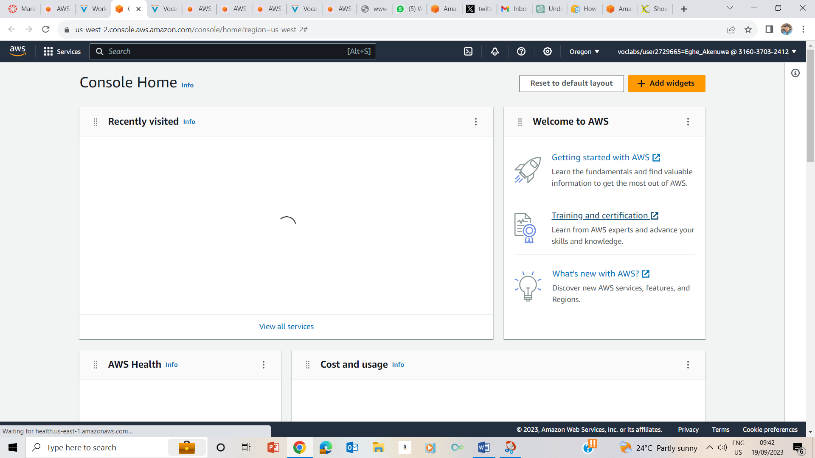

1-4

## Task 1: Use SSH to connect to an Amazon Linux EC2 instance

### Windows Users: Using SSH to Connect

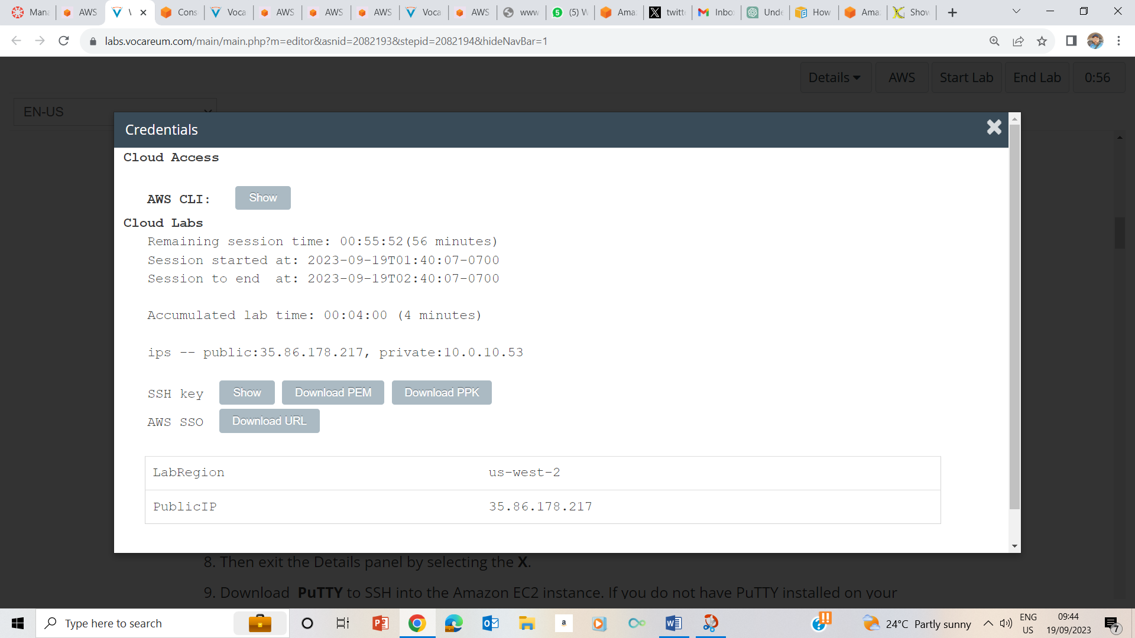

5-8. Clicked on the AWS dropdown box, clicked on show, downloaded ppk on the credentials page, made a note of the public ip address – 35.86.178.217 and exited the details panel by pressing the x.

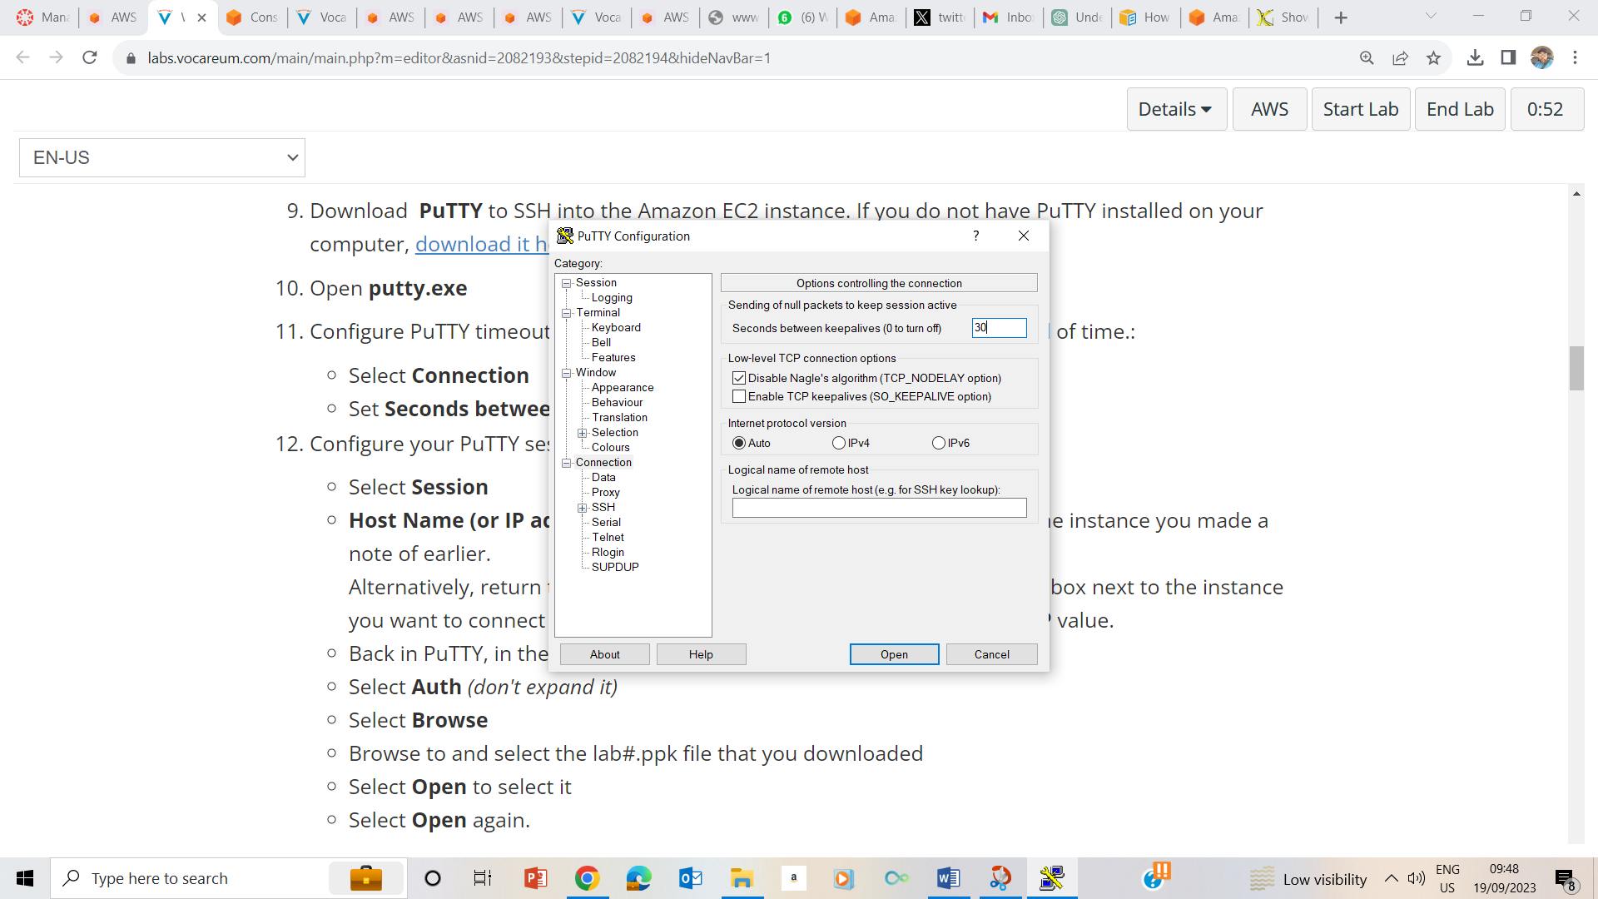

9 configured putty connection time to 30 seconds

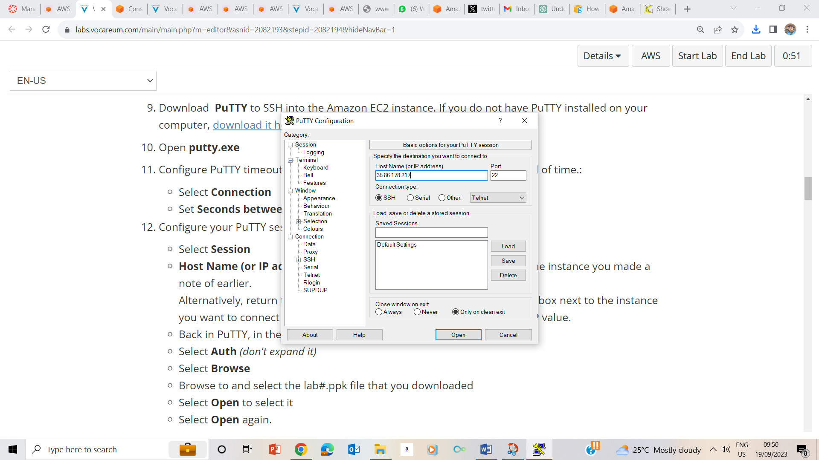

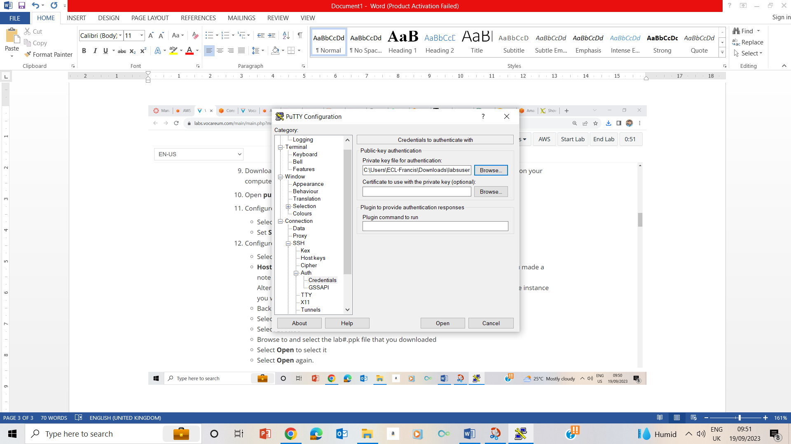

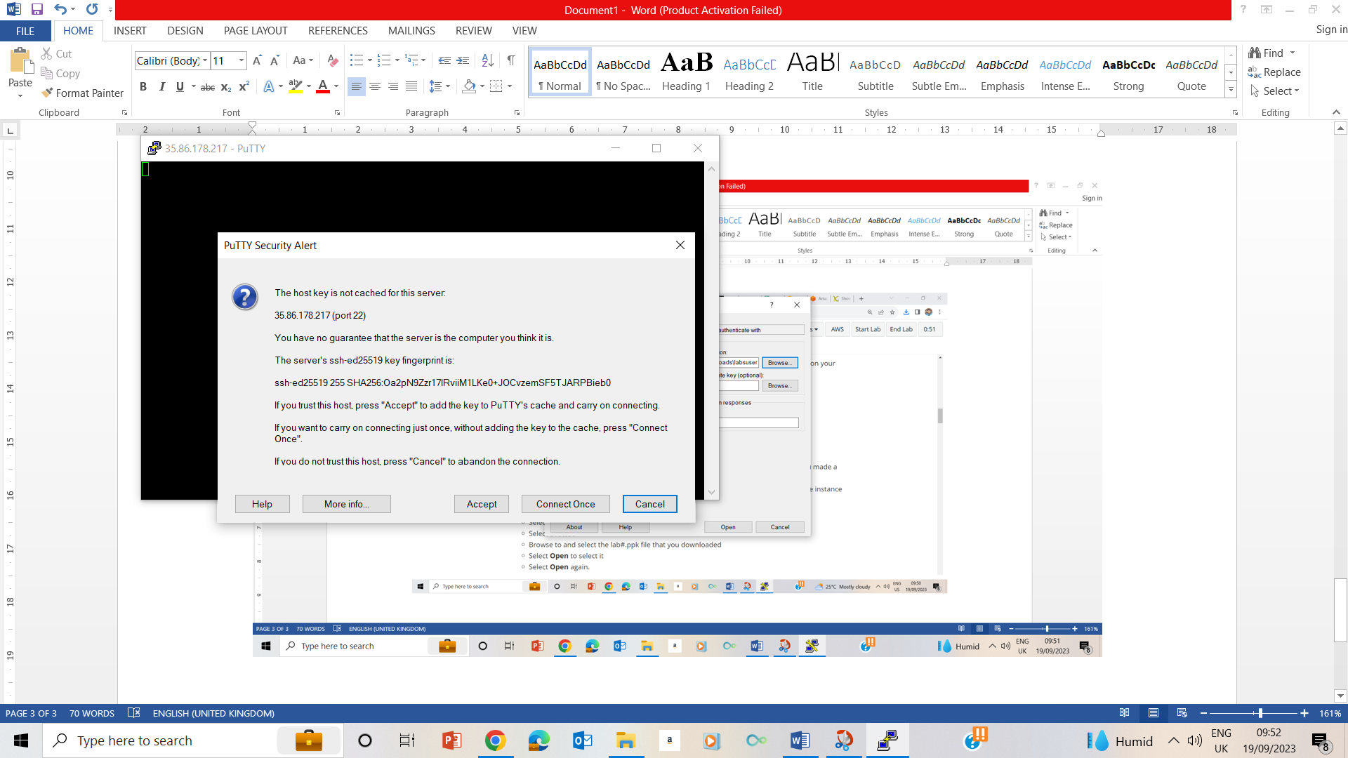

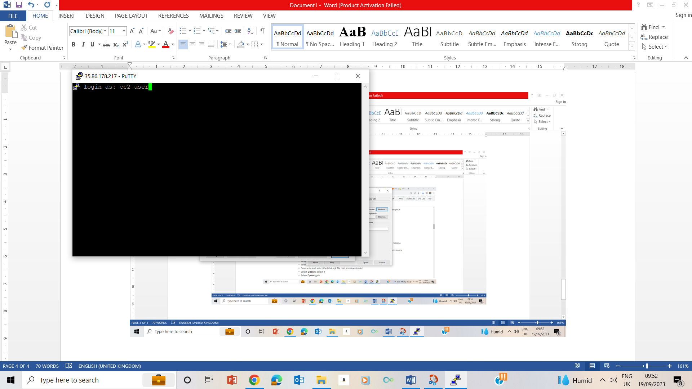

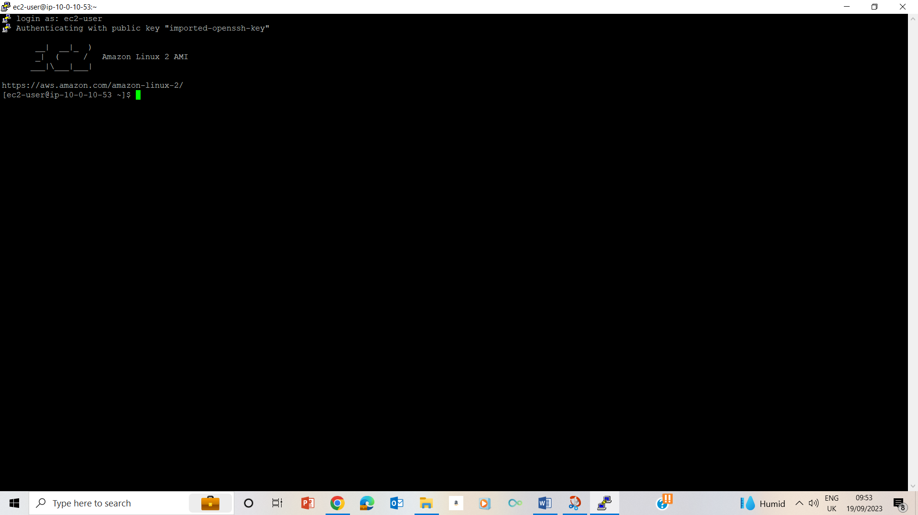

10-15 Configuring the Putty

## Task 2: Use the tee command

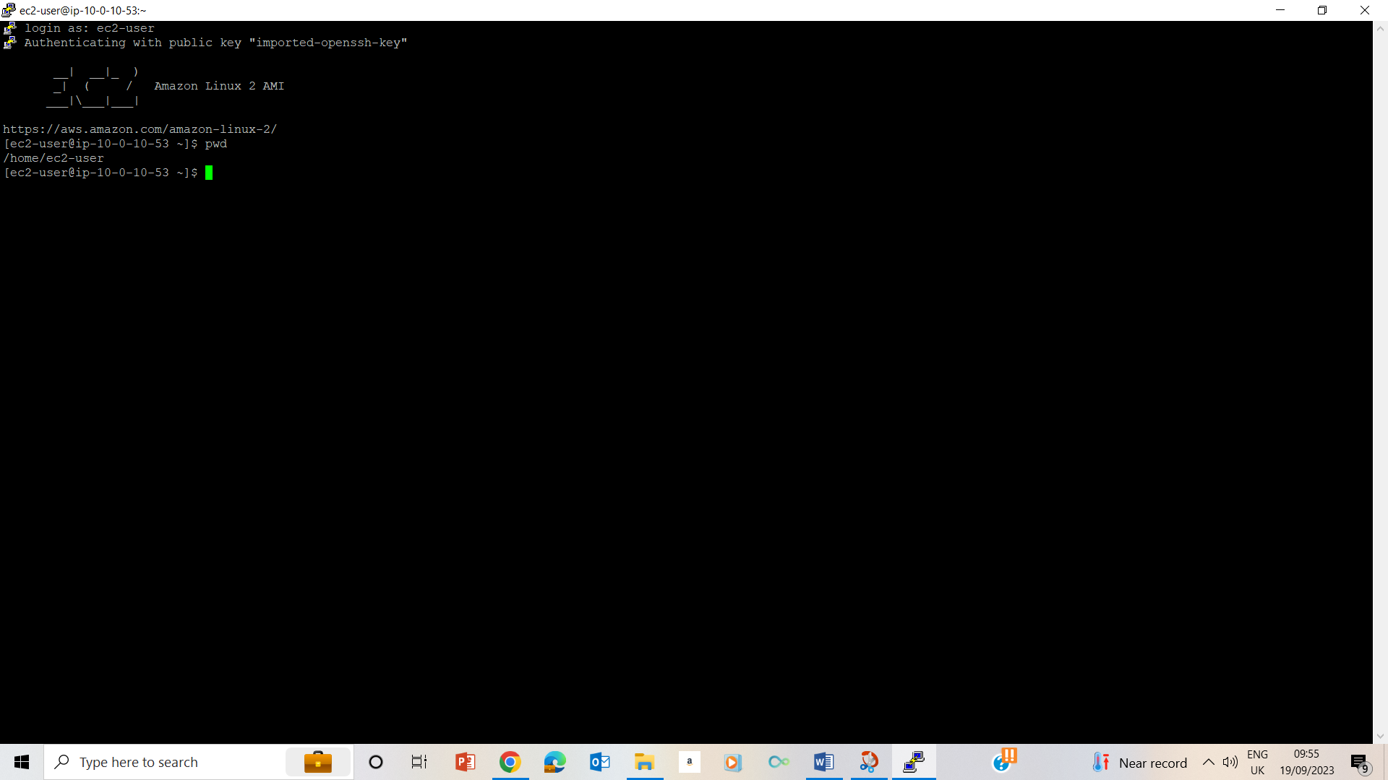

24. Used pwd to validate that I am in the home folder /home/ec2-user

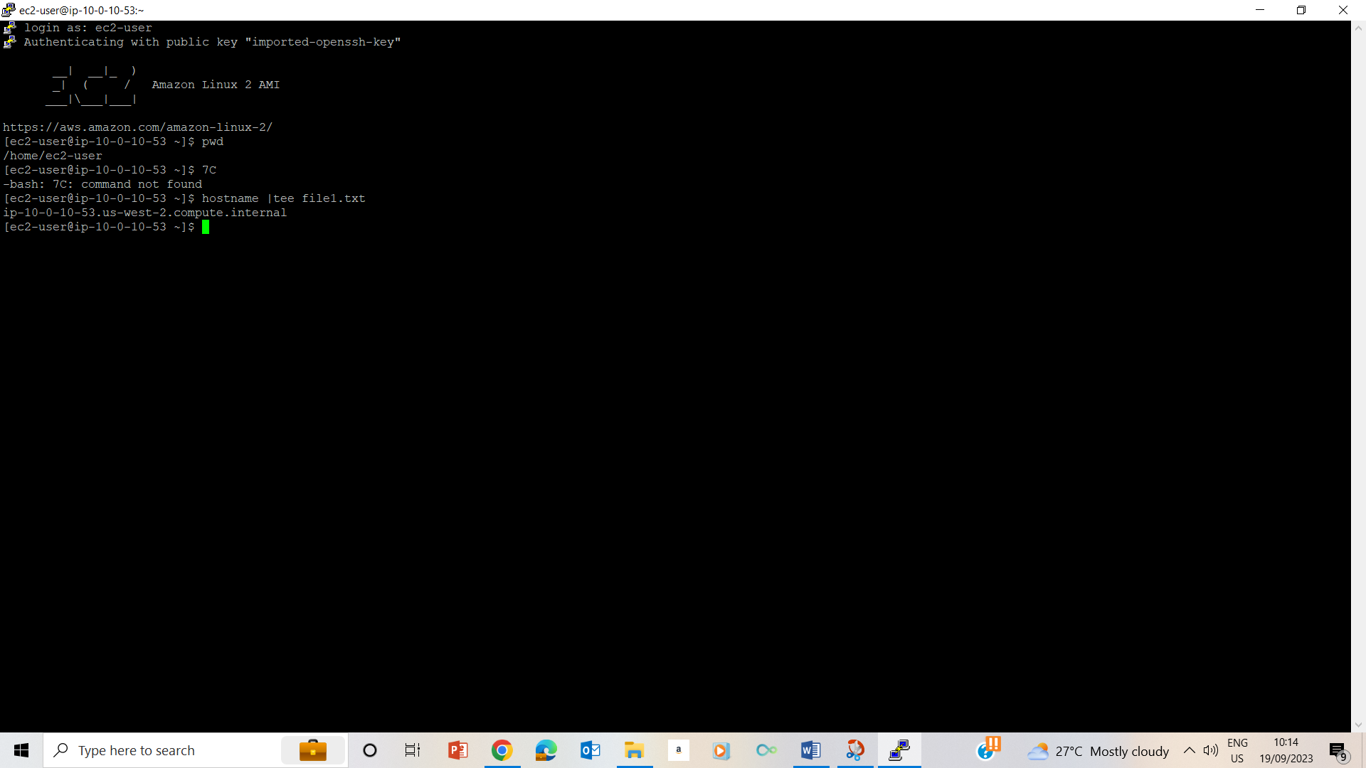25.



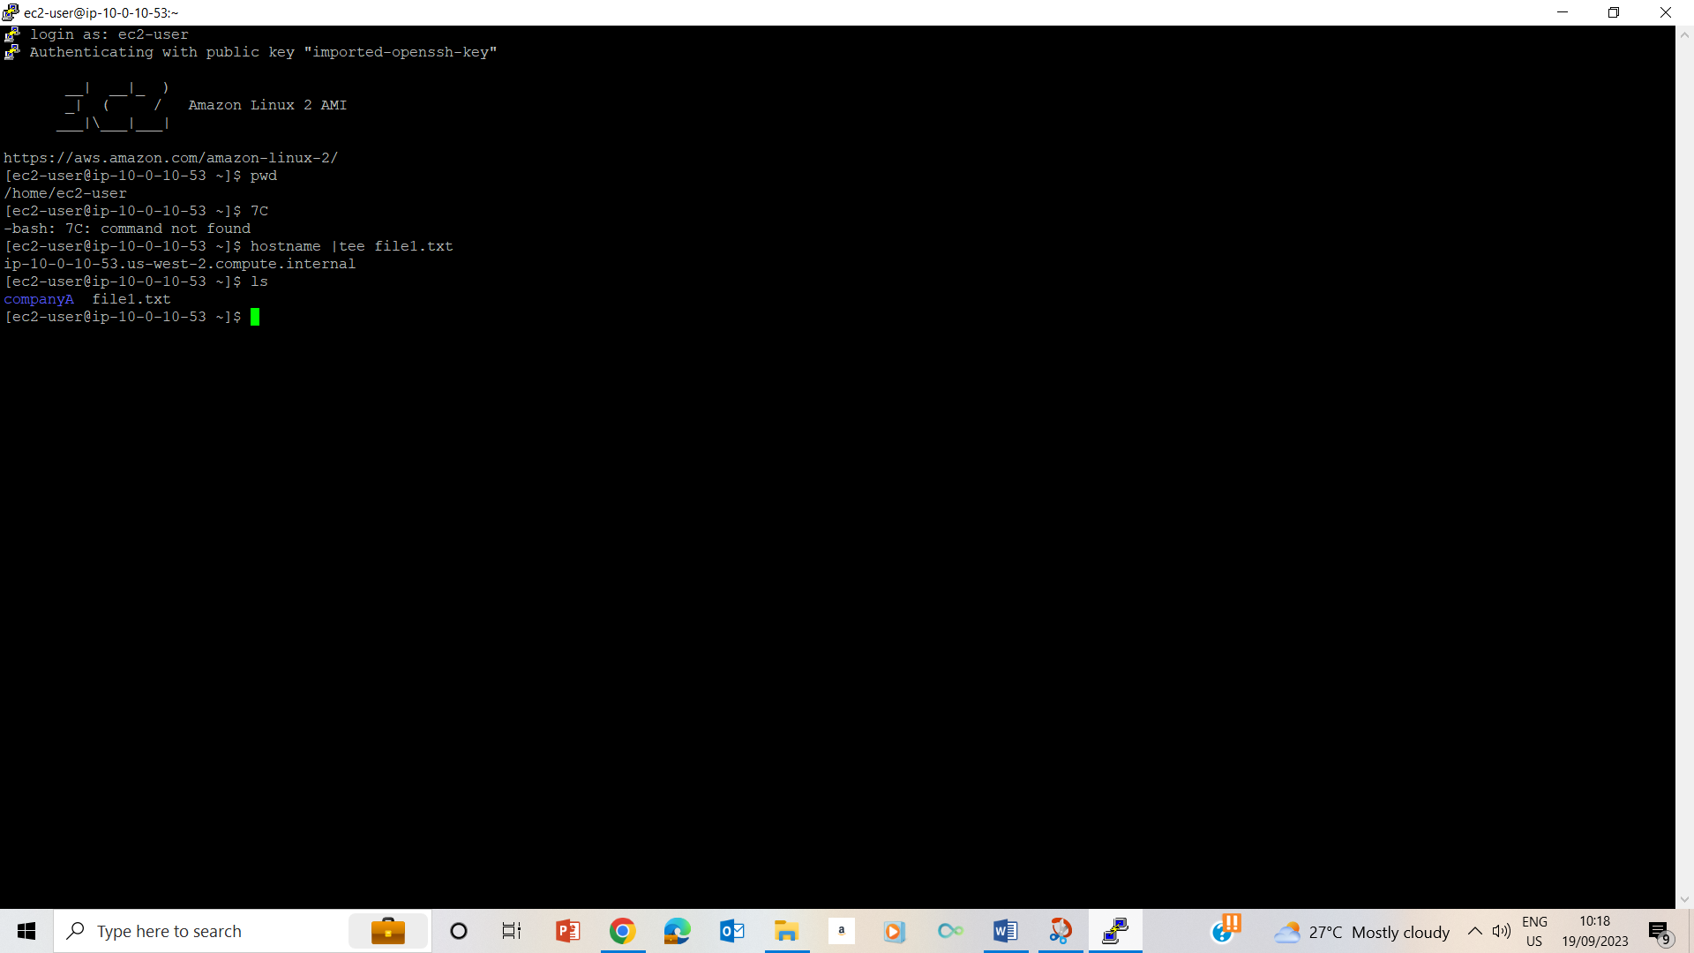

26

## Task 3: Use the sort command and pipe operator

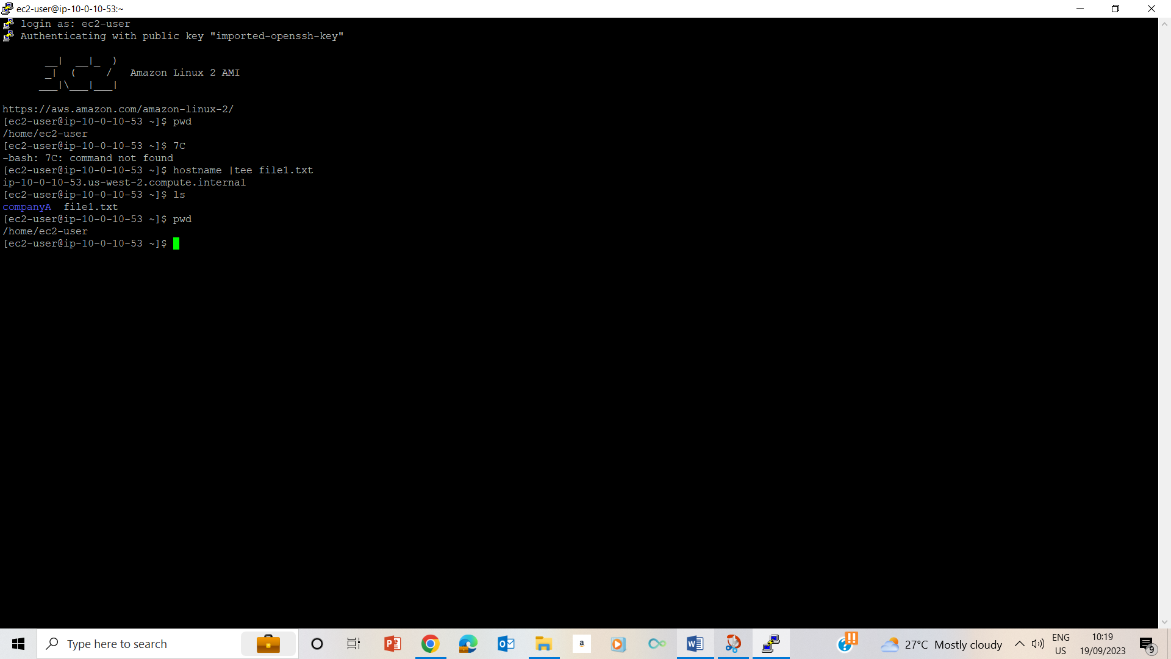

27. Used pwd to confirm that I am in the /home/ec2-user folder.

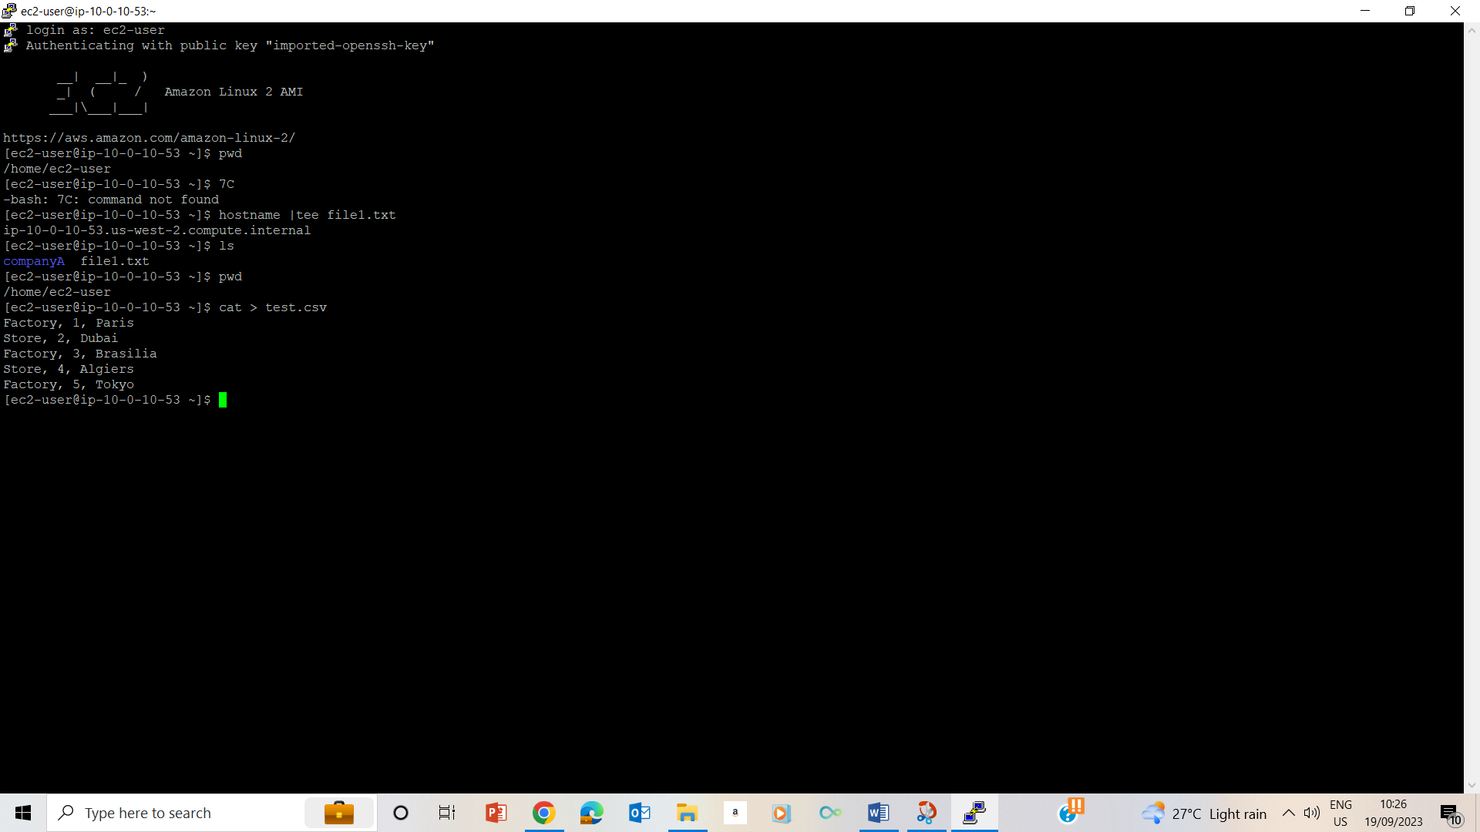

28-30. Enter cat > test.csv and press Enter to list the names and pressed ctrl+d to exit.

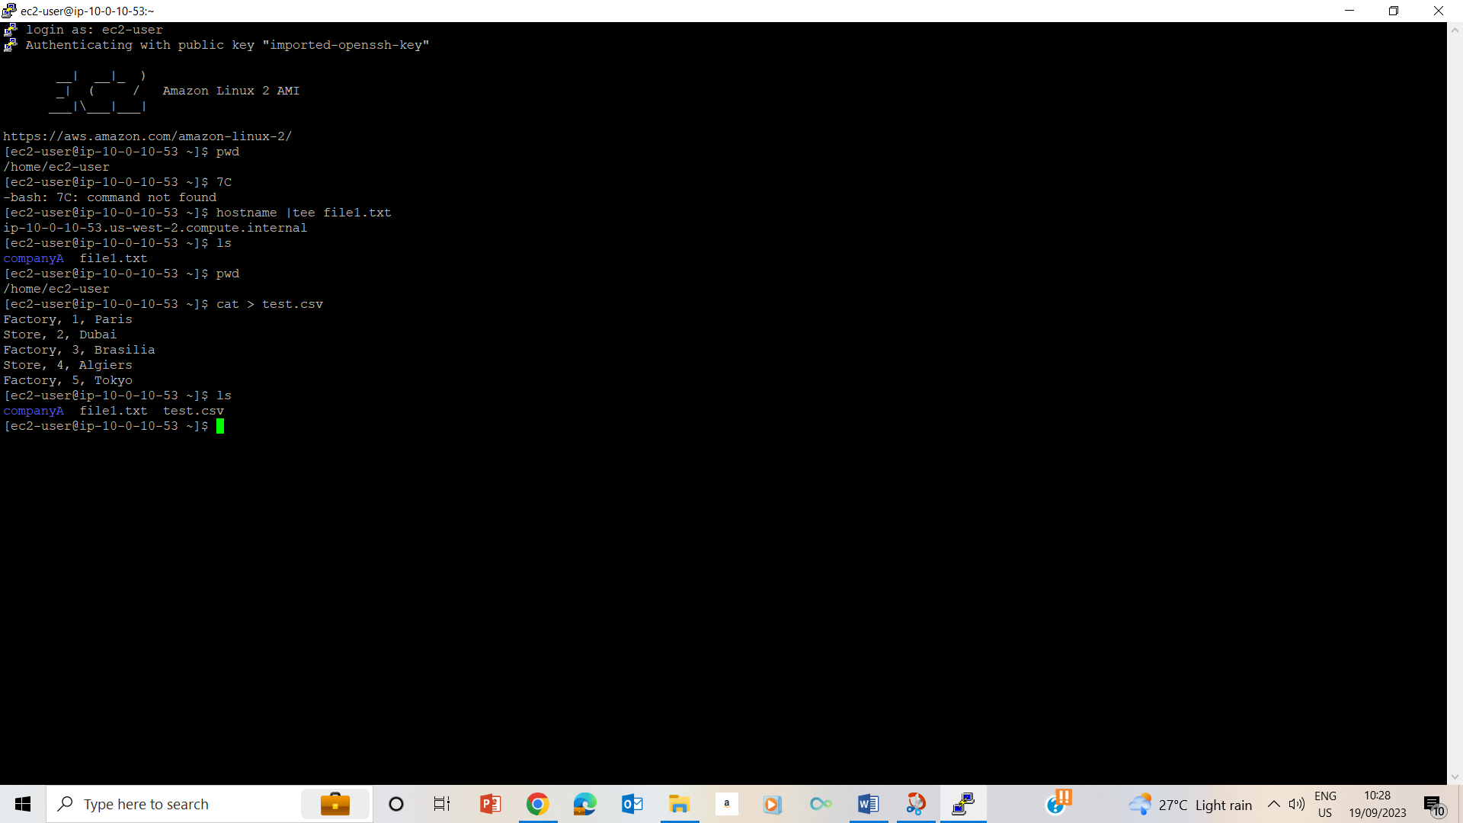

31. used ls command to check if the test.csv file is in the folder.

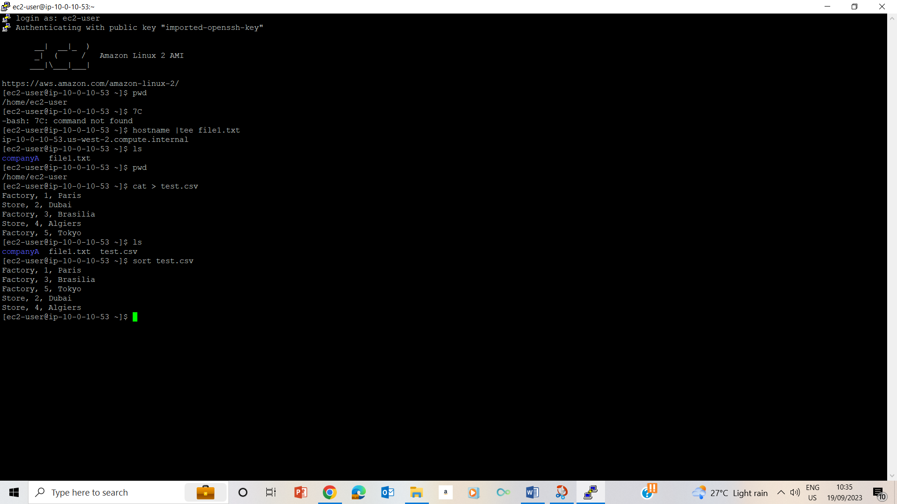

32. sorting test.csv contents.

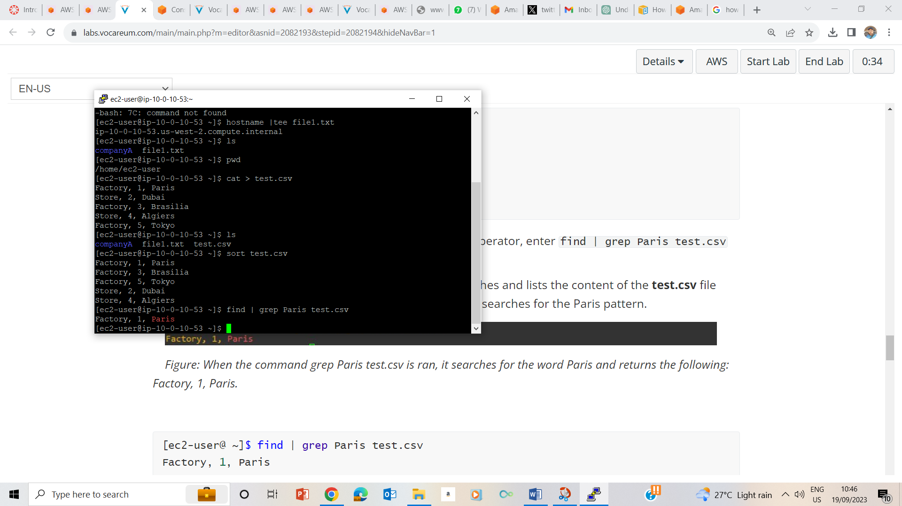

## Task 4: Use the cut command

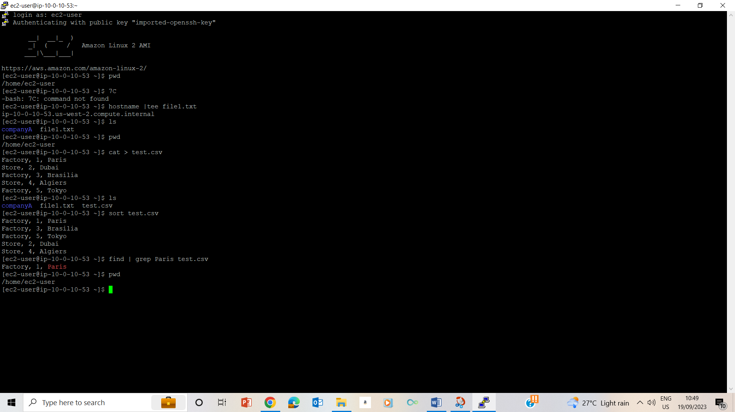

35-37. Used cat > cities.csv and entered cities and headquarters and used ctrl+d to exit the file.

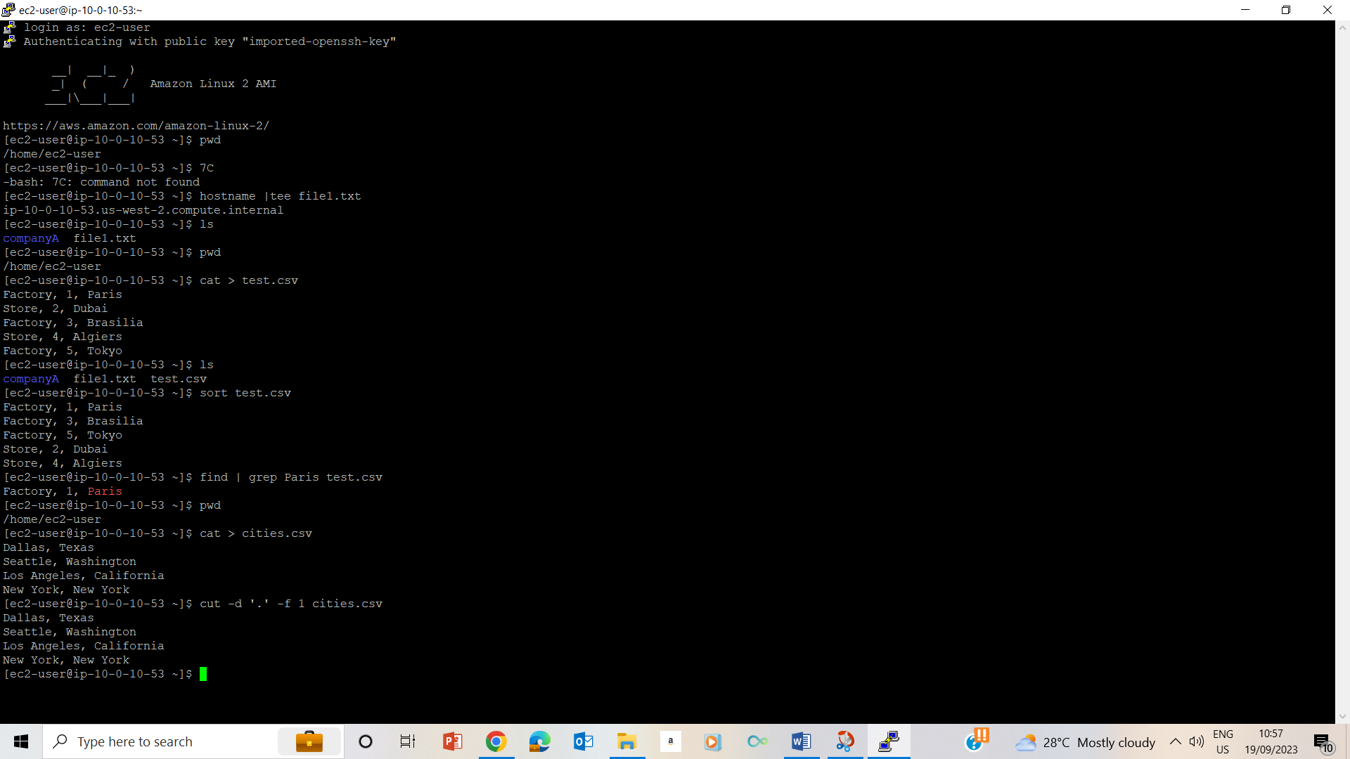

38. Usage of cut command.

### Additional Challenge:

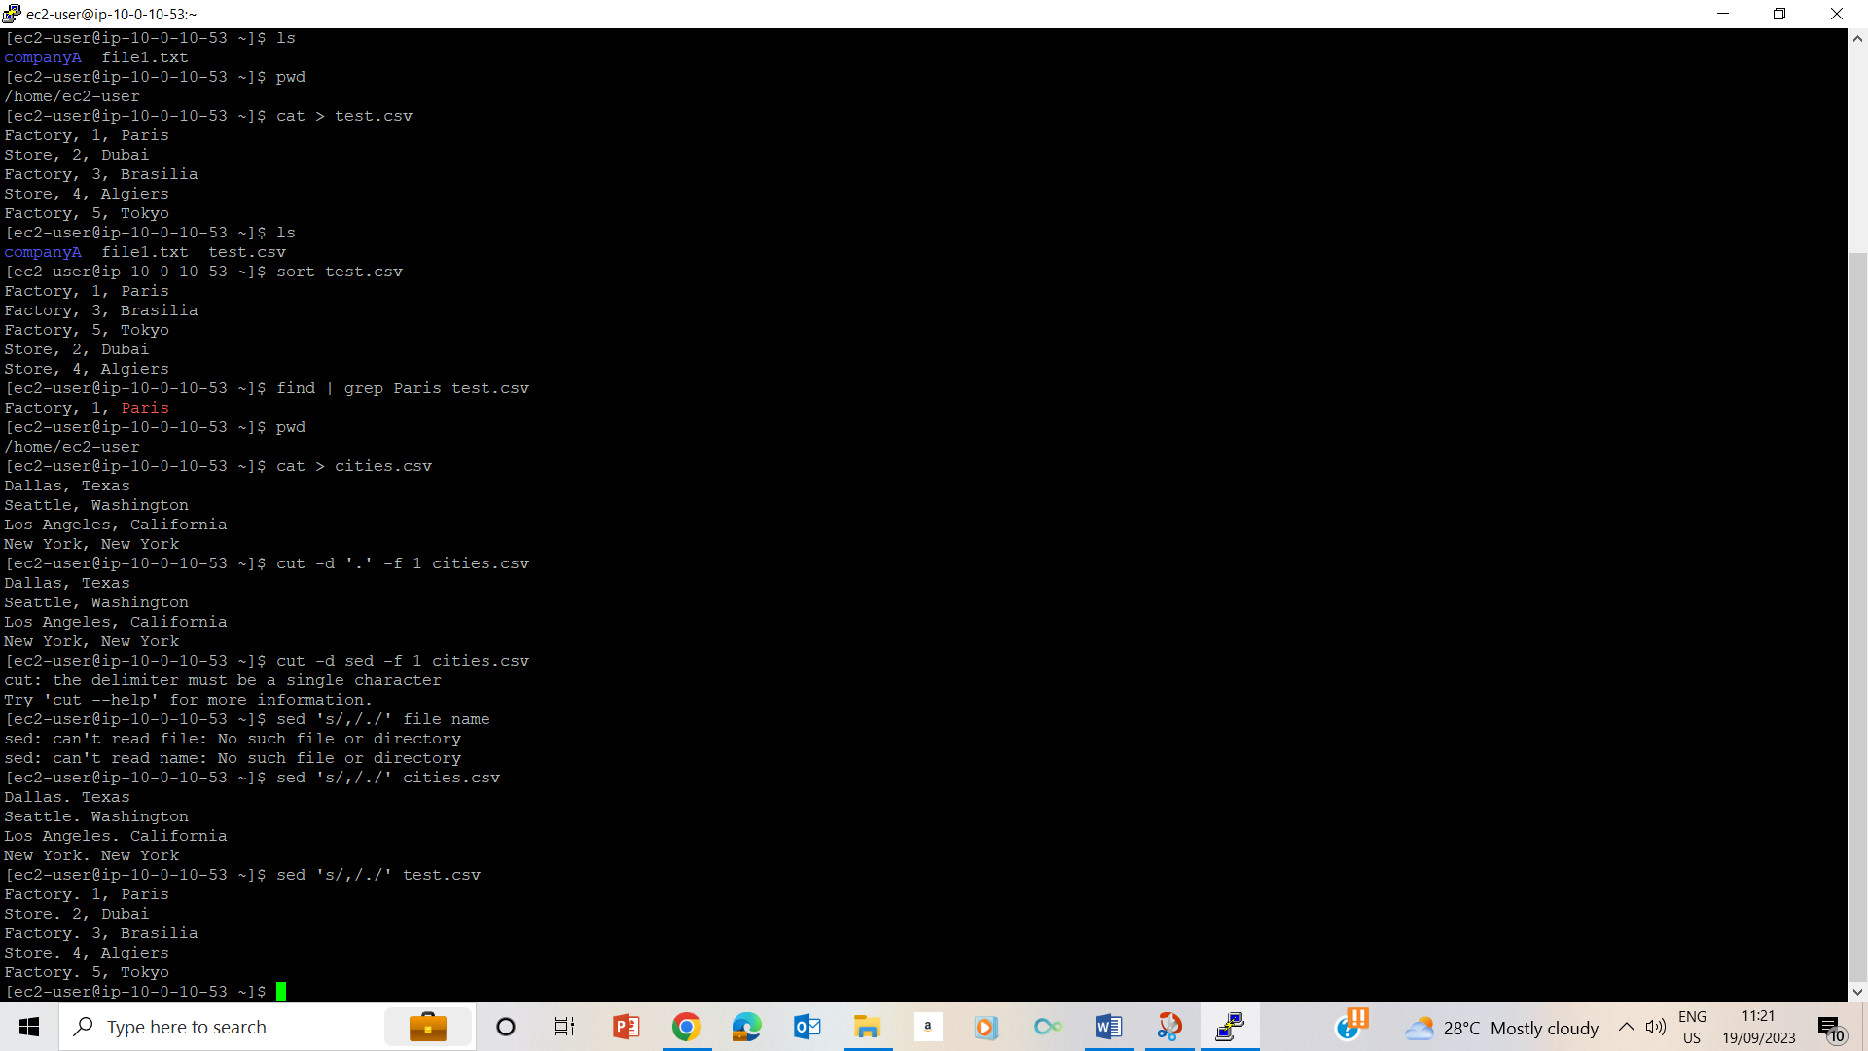

## Lab Complete

